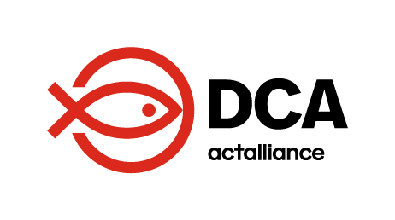

**REQUEST FOR PROPOSALS**

**Re- Advertised**

**Private Security Service Provider for DCA Rhino Camp Office**

**1. Background**

DanChurchAid (DCA) operates in Uganda’s West Nile region, with a coordination office in Yumbe town and a satellite office in Rhino Camp Settlement Base Camp. The Rhino Camp office was established to support the effective implementation of key projects, including:

The satellite office facilitates DCA’s efforts to deliver timely and hands-on technical support to local implementing partners and target communities within Terego and Madi-Okolo districts.

Historically, DCA has operated similar satellite offices in locations such as Imvepi, Zombo, and Arua to support projects related to disaster preparedness and response, environment and energy, and food security, among others. Many of these satellite offices were closed as the associated projects concluded, necessitating staff layoffs.

**2. Purpose of the Terms of Reference (ToR)**

This ToR outlines the terms, conditions, and process for recruiting a private security service provider to secure the Rhino Camp satellite office. The procurement process will be conducted through a fair, transparent, and competitive approach to ensure value for money and alignment with DCA policies and donor requirements.

**3. Objectives of the Security Services**

The primary objectives for engaging a private security service provider include:

* Ensuring the safety and security of DCA staff, assets, and premises in Rhino Camp.
* Mitigating potential risks associated with operating in a dynamic environment, including theft, vandalism, and unauthorized access.
* Establishing a professional security presence to foster a secure and productive work environment.

**4. Scope of Work**

The selected service provider will be responsible for:

* Providing round-the-clock (24/7) security services, by assigning three unarmed guards (two for night time; and one for day time).
* Monitoring and controlling access to the office premises.
* Conducting routine patrols and inspections of the premises.
* Responding promptly to security incidents and emergencies.
* Submitting regular security reports to the DCA office.
* Liaising with local law enforcement and other relevant stakeholders to enhance security measures.

**5. Qualifications and Experience of the Service Provider**

The ideal service provider must:

* Be a licensed and registered security firm in Uganda.
* Have at least 5 years of experience providing similar services to international organizations or NGOs.
* Demonstrate a strong understanding of the security context in Rhino Camp and the broader West Nile region.
* Have a trained and professional workforce, including appropriate uniforms and equipment.
* Provide evidence of adequate insurance coverage for its operations.
* Be able to offer reliable and responsive communication channels for coordination.

**6. Selection Criteria**

The evaluation process will focus on the following criteria:

* Technical Proposal: Understanding of the assignment, proposed methodology, and appproach.
* Past performance with similar clients, references, and regional expertise.
* Competitiveness and justification of the proposed budget.
* Valid registration documents, licenses, and adherence to DCA’s ethical and perational standards.

**7. Submission Requirements**

Interested service providers must submit the following:

* A detailed technical and financial proposal.
* Company profile and registration documents.
* References from at least three previous clients.
* Proof of insurance coverage. (A MUST)
* Any other relevant documentation.

**8. Duration of the Contract**

The contract will initially be awarded for one year, with the possibility of renewal based on performance and project needs.

**9. Application Deadline**

Proposals must be submitted by 14th February 2025 to emails [geok@dca.dk](mailto:geok@dca.dk) [elsi@dca.dk](mailto:elsi@dca.dk)., [dina@dca.dk](mailto:dina@dca.dk) Late submissions will not be considered.

**10. Confidentiality** All information shared during the procurement process must remain confidential and used solely for the purpose of evaluating proposals.